https://www.truecar.com/used-cars-for-sale/listing/1FTPW125X5KE84220/2005-ford-f-150/
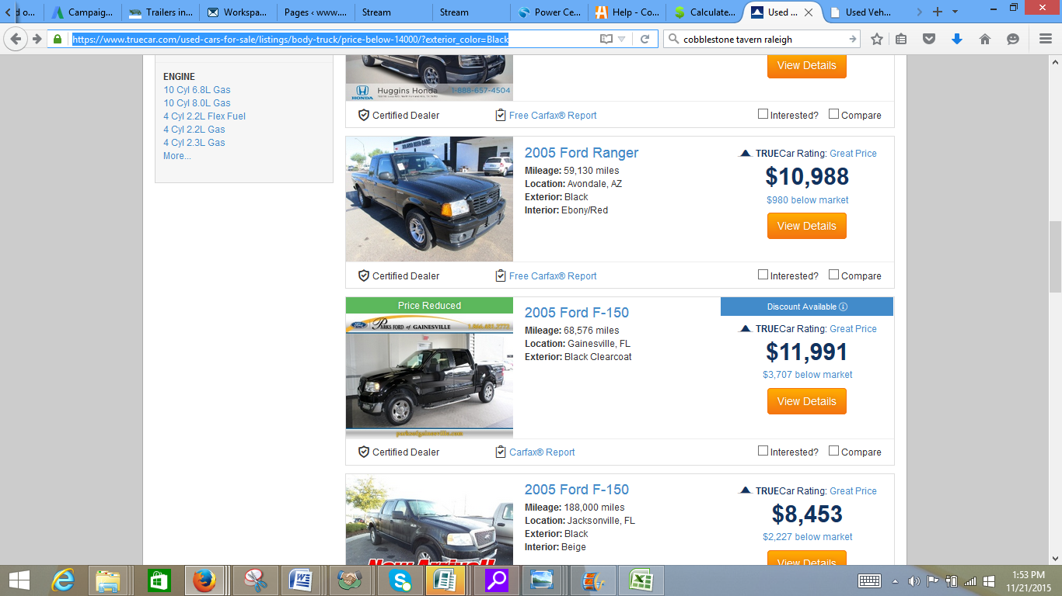
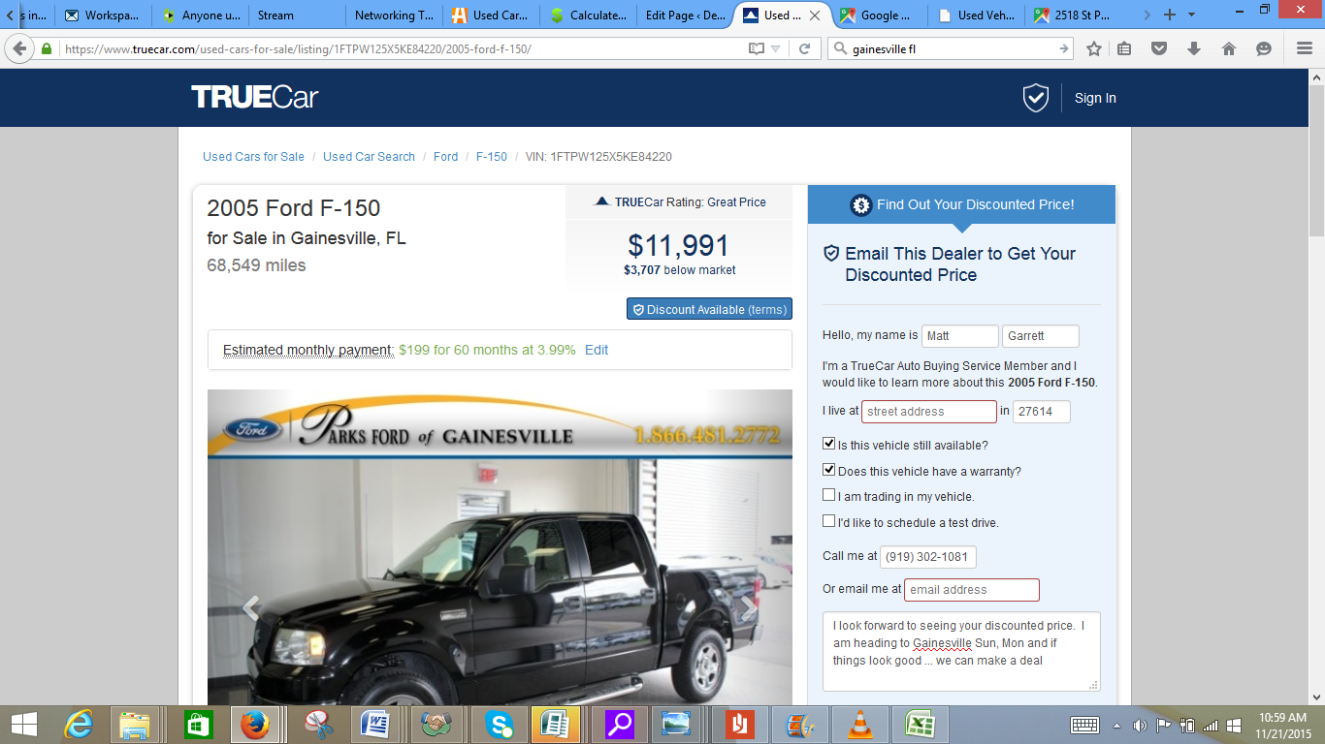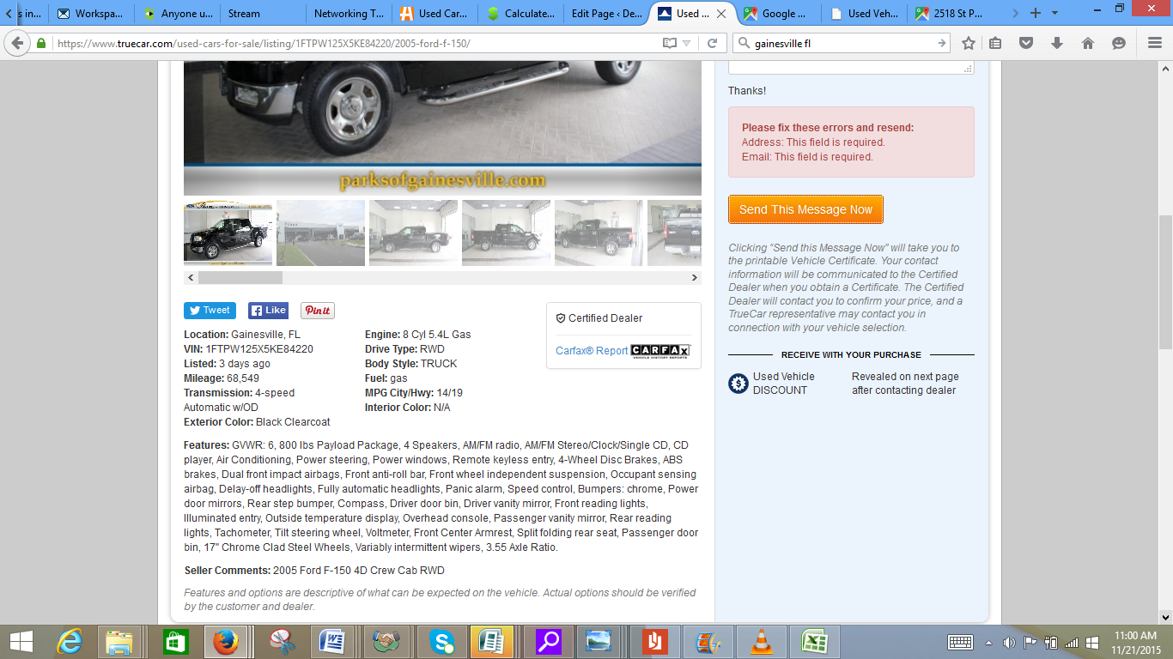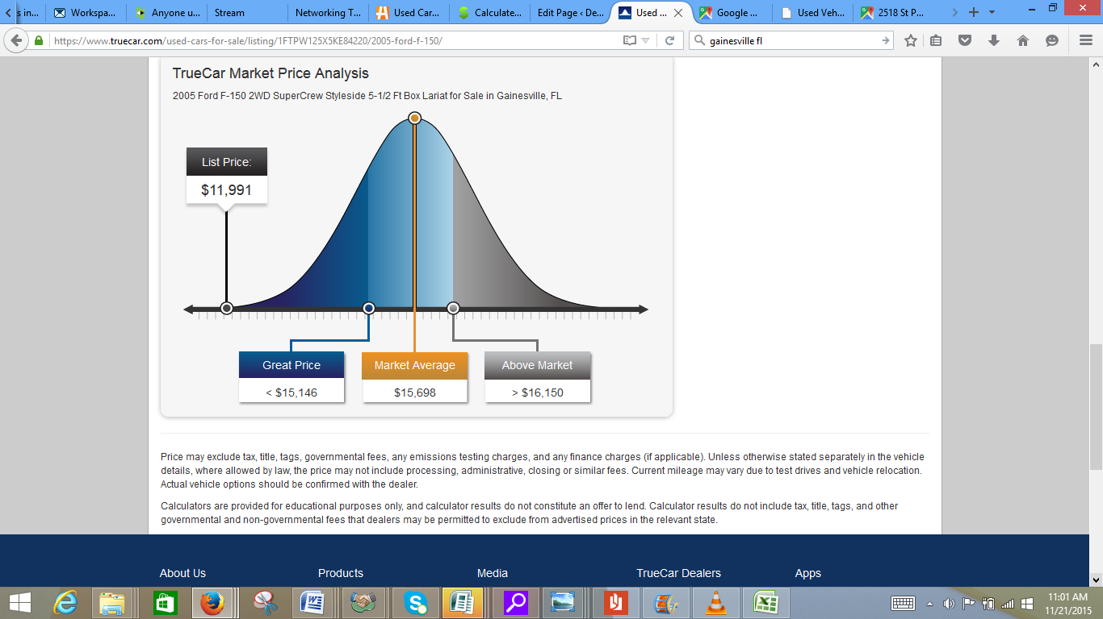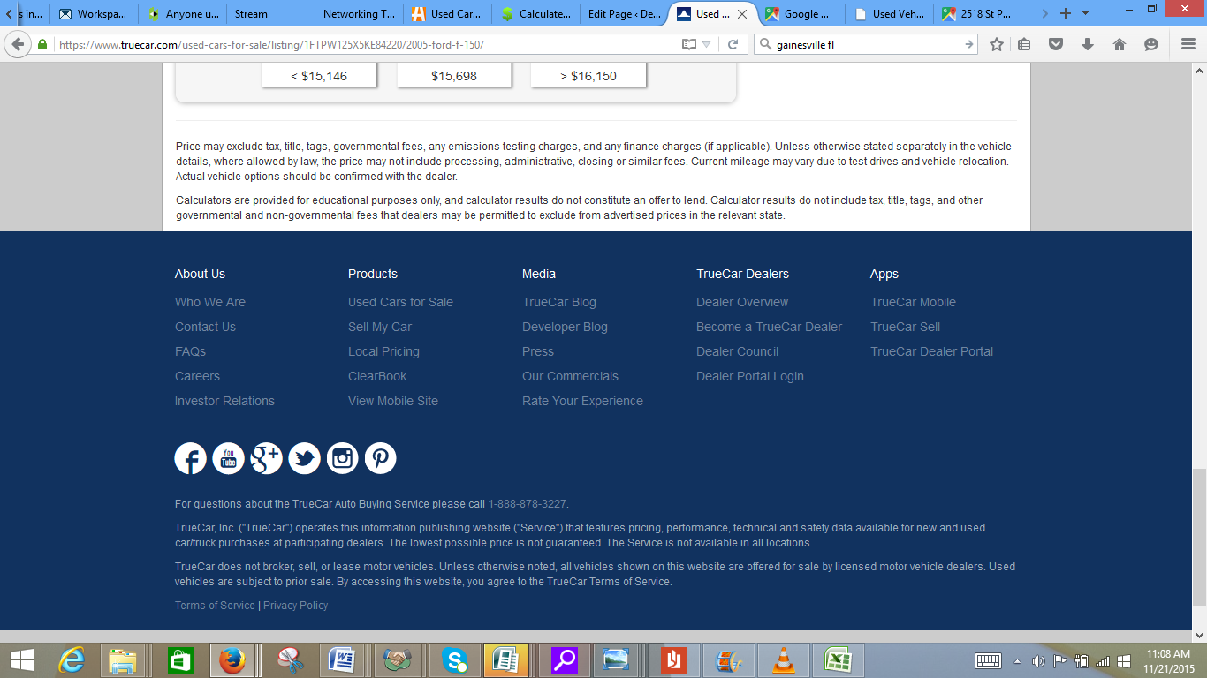
ccccc

http://www.gainesvilleford.net/used-inventory/index.htm?saveFacetState=true&accountId=&normalBodyStyle=&normalExteriorColor=Black&engine=&normalTransmission=&normalDriveLine=&odometer=&lastFacetInteracted=inventory-listing1-facet-anchor-normalExteriorColor-0
http://www.gainesvilleford.net/used/Ford/2005-Ford-F-150-1ccf5c7a0a0e0a6b21e766a6f7772306.htm?searchDepth=1:22



